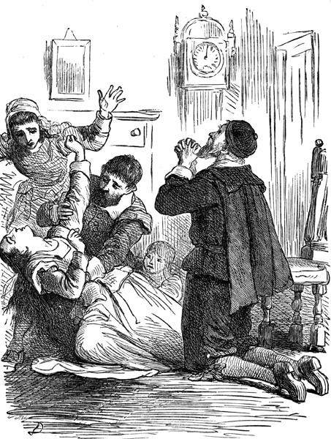
The Salem Witch Trials
HONORS 412
Fall 2014

Mondays & Wednesdays, 9:30 a.m.-10:45 a.m.
120 Honors Hall

Dr. Kevin L. Gooding
KLGooding@mail.wvu.edu
Office: 131B Honors Hall
Office Hours: M/W 10:45-11:30, 12:45-1:30
Other Hours by Appointment

Course Description:
The Salem Witch Trials of 1692 are one of the iconic events in American history. Almost from the conclusion of the final trial, these tragic events have held a firm place in the American imagination. This class examines the trials themselves and the various ways in which people down to the present day have interpreted them. Class members will examine trial records, scholarly works, poems, artwork, drama, film, and works of fiction to discover how Americans have, through the telling and retelling of this story, attempted to fit these events into our national identity.

Course Objectives:
Students in this course will:
- Place the Salem Witch Trials within the context of witchcraft in the pre-modern and early modern northern Atlantic world.
- Place the Salem Witch Trials within the context of 17th century Puritan life and belief.
- Become familiar with one particular trial.
- Read and analyze a scholarly interpretation of the Salem Witch Trials.
- Gain an understanding of how the trials and their participants have been depicted by artists, poets, novelists, and dramatists, and if and how those expressions have changed over time.
- Be able to evaluate a fictional work on the Salem Witch Trials with regards to historical accuracy.

Required Reading:
- Available at WVU Bookstore:
  - Miller, Arthur, The Crucible
  - Pötzsch, Oliver, The Hangman’s Daughter (AmazonCrossing, 2010)
  - Rinaldi, Ann, A Break with Charity: A Story about the Salem Witch Trials (Harcourt, 2003)
- The Salem Witchcraft Papers: Verbatim Transcriptions Of The Court Records In Three Volumes, Edited by Paul Boyer and Stephen Nissenbaum (Da Capo Press: New York, 1977.) Available at: http://etext.virginia.edu/salem/witchcraft/texts/transcripts.html
- One of the Following
  - Boyer, Paul and Stephen Nissenbaum. Salem Possessed: The Social Origins Of Witchcraft (Cambridge, Mass., Harvard University Press, 1974.)—Available as an e-book through the WVU Library.
  - Godbeer, Richard. The Devil's Dominion: Magic And Religion In Early New England (New York: Cambridge University Press, 1992.).—On Reserve
  - Karlsen, Carol F. The Devil In The Shape Of A Woman : Witchcraft In Colonial New England (New York : Norton, 1998.).—On Reserve
  - Norton, Mary Beth. In The Devil's Snare: The Salem Witchcraft Crisis Of 1692 (New York: Alfred A. Knopf, 2002.).—On Reserve
  - Rosenthal, Bernard. Salem Story: Reading The Witch Trials Of 1692 (New York: Cambridge University Press, 1993.).—On Reserve
  - Starkey, Marion L. The Devil In Massachusetts: A Modern Enquiry Into The Salem Witch Trials (N.Y., Doubleday & Co., [1969]).—On Reserve.

Assignments:
There will be four assignments for which students will earn grades in this class:
- Review of The Hangman’s Daughter—Write a 3-5 page paper discussing the depiction of witchcraft in the Hangman’s Daughter in light of class lectures on and discussion of witchcraft in pre-modern Europe. This paper is worth 50 points and is due on Wednesday, September 3, 2014.
- Witch Trial Analysis:
  - Write a 5-8 page paper analyzing one single witch trial (use Boyer and Nissenbaum’s “The Salem Witchcraft Papers” as your primary source) using John Demos’ Collective Portrait of a Witch (as presented and discussed in class) as your interpretive framework. You must provide basic information about the accused, the accuser(s), the nature of the accusation, and the trial outcome, and discuss the ways in which your accused individual does or does not fit Demos’ portrait. The paper will be worth 50 points.
  - Present to the class the outcome of your analysis. Please be as creative as possible with this presentation; an endless parade of PowerPoint presentations will make your professor’s eyes glaze over. The presentation will be worth 25 points.
  - The paper is due the class session before you are scheduled to present.
- Review of a Scholarly Work
  - Choosing one of the scholarly works listed under “Required Reading,” write a 3-5 page paper (worth 50 pts.) in which you describe:
    - The author’s explanation of the Witch Trials (why did they happen?)
    - How the author supports his or her explanation. What data does this author utilize to support his or her explanation?
    - How this interpretation does or does not fit with your understanding of the trial you examined for Assignment #2.
  - Present your findings to the class (25 pts.)
  - The paper must be done individually, but the presentation can be done in a group.
  - The paper is due the class session before you are scheduled to present.
- Review of A Break with Charity—Based upon what you know from your own examination of one of the trials and the scholarly work you read for Assignment #2, write an 8-10 page paper analyzing how accurately Ann Rinaldi depicts the Salem Witch Trials in her book for young readers, A Break with Charity. This paper, worth 150 points, will be your FINAL EXAM. Due Date: Scheduled Final Exam date.

Attendance Policy:
I do not and will not be taking attendance. However, if you plan to earn a superior grade in this class, it would benefit you to be in attendance at every class period. Material covered in class will help you complete the assignments more successfully.

Grading:
Review of The Hangman’s Daughter……...………………………………………..50 pts.
Witch Trial Analysis………………………………75 pts. total (paper 50/presentation 25)
Scholarly Review………………………………….75 pts. total (paper 50/presentation 25)
Final Review of A Break with Charity……………………………………………..150 pts.
Total Points………………………………………………………………………...350 pts.

Scale:
A 329-350 points
A- 315-328 points
B+ 305-314 points
B 294-304 points
B- 280-293 points
C+ 270-279 points
C 259-269 points
C- 245-258 points
D+ 235-244 points
D 224-234 points
D- 210-223 points
F ≤ 209 points
Course Schedule:
August 18 Introduction to Course, Syllabus, Expectations
August 20 Background and Importance of the Salem Witch Trials
August 25 Witchcraft in Pre-Modern Europe
August 27 Witchcraft in Pre-Modern Europe
September 1 Labor Day—No Class
September 3 Book Discussion: The Hangman’s Daughter
Review of the Hangman’s Daughter due
Selecting Trials
September 8 The Puritans— Who They Were…and Were Not
September 10 The Puritans—Naughtiness, Gender, and the Kids
September 15 The Puritans—Trouble in Mind
September 17 Salem and Witchcraft
September 22 The Witch Trials—The Accused, or “How Do You KNOW She’s a Witch?”
September 24 The Witch Trials—The Accused: Student Presentations
September 29 The Witch Trials—The Accused: Student Presentations
Selecting Scholarly books
October 1 The Witch Trials—The Accused: Student Presentations
October 6 The Witch Trials—The Accused: Student Presentations
October 8 Guest Presenter
October 13 No Class—Fall Break
October 15 Playing Siskel & Ebert, pt. 1
October 20 Playing Siskel & Ebert, pt. 2
October 22 Witches and Scholars—Introduction
October 27 Witches and Scholars—In-Class Work Period
October 29 SURPRISE!
November 3 Witches and Scholars—Student Presentations
November 5 Witches and Scholars—Student Presentations
November 10 The Crucible and Its Time, or, How Long Is It Really from 1692 to 1953?
Read The Crucible
November 12 “The Crucible”
November 17 “The Crucible”
November 19 Talking about “The Crucible”
November 24 Thanksgiving Break—No Class
November 26 Thanksgiving Break—No Class
December 1 Witches & Artists
December 3 Witches & Poets
December 8 Wrap-Up
December 11-17 Final Paper due on Exam Day

Academic Dishonesty:
In keeping with the West Virginia University Student Conduct Code, any form of academic dishonesty will NOT be tolerated in this class [for a definition of Academic Dishonesty, consult “Article III: Proscribe Conduct” (http://studentlife.wvu.edu/studentconductcode.html)]. Any instances of such conduct will earn the student a failing grade for the assignment in question, an F for the entire course, or an Unforgivable F, depending on the severity of the infraction. The process by which such infractions are handled is viewable at http://docs.facultysenate.wvu.edu/08Files/AcademicDishonestyFlowChart.pdf

